# Spring Boot 3 Microservice Notes

- Spring Boot 3

- Integration Tests using Latest Testing Techniques

- Spring Cloud Feign for inter service communication

- API Gateway implementation using Spring Cloud Gateway MVC instead of Spring Cloud Gateway with Webflux

- Add Circuit Breaker Logic in API Gateway

- Security using latest Keycloak

- Distributed Tracing using Grafana Stack instead of Slueth

- Deployment using Kubernetes

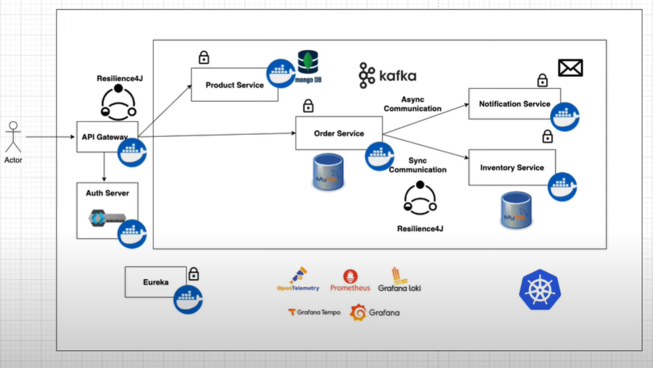

4 Microservices:

1. Product Service: Product catalog, stored in MongoDB (NoSQL)

2. Order Service: handles orders, stored in MySQL (RDBMS)

3. Notification Service: stateless, no db, asynchronous using Kafka.

4. Inventory Service: handles inventory, synchronous using Resilience4J

- API Gateway: acts as the gateway to access microservices

- Auth Server: Keyloak, for app’s security.

- Eureka: server and client for registration of microservices

- Grafana: for monitoring and dashboard

- GrafanaLoko: for logs

- Grafana Tempo: for distributed tracing

- Prometheus: for metrics

- Containerized all services using Docker

- Run all Docker containers using Docker compose.

- Migrate all Docker compose workloads to Kurbenetes

Part 1:

- setup docker-compose.yml

- Started with product-service

Run the docker compose with this command: docker compose up -d

Part 2:

- setting up order-service

- something new with me is Flyway Migration dependency. It helps us version control database.

- we can write our database migration scripts under resources/db/migration. (This is automatically created when we have the pom dependency for flyway).

- naming convention of file should be “V<number>__<name>.sql”

Part 3:

Microservice-to-Microservice Synchronous Communication:

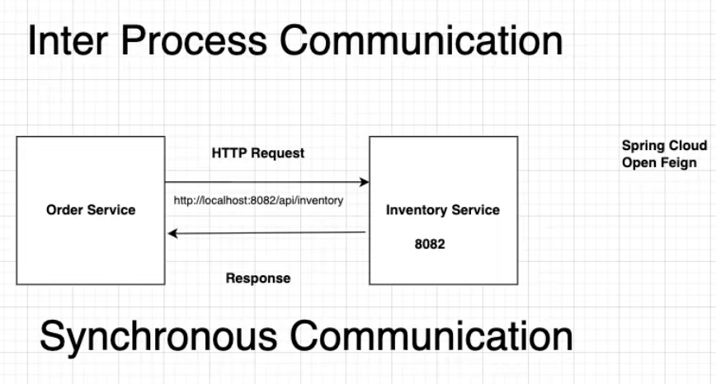

- Learned about OpenFeign: helps with calling microservice-to-microservice.

Add this annnotation to register the app:

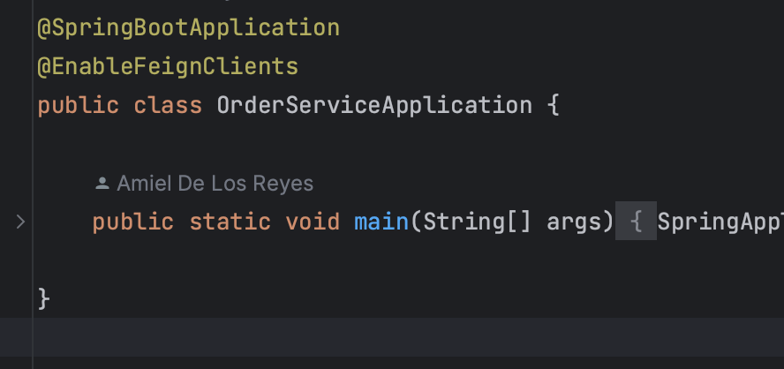

This is how we register `inventory-service` to `order-service` to be able to call methods in inventory service inside order-service.

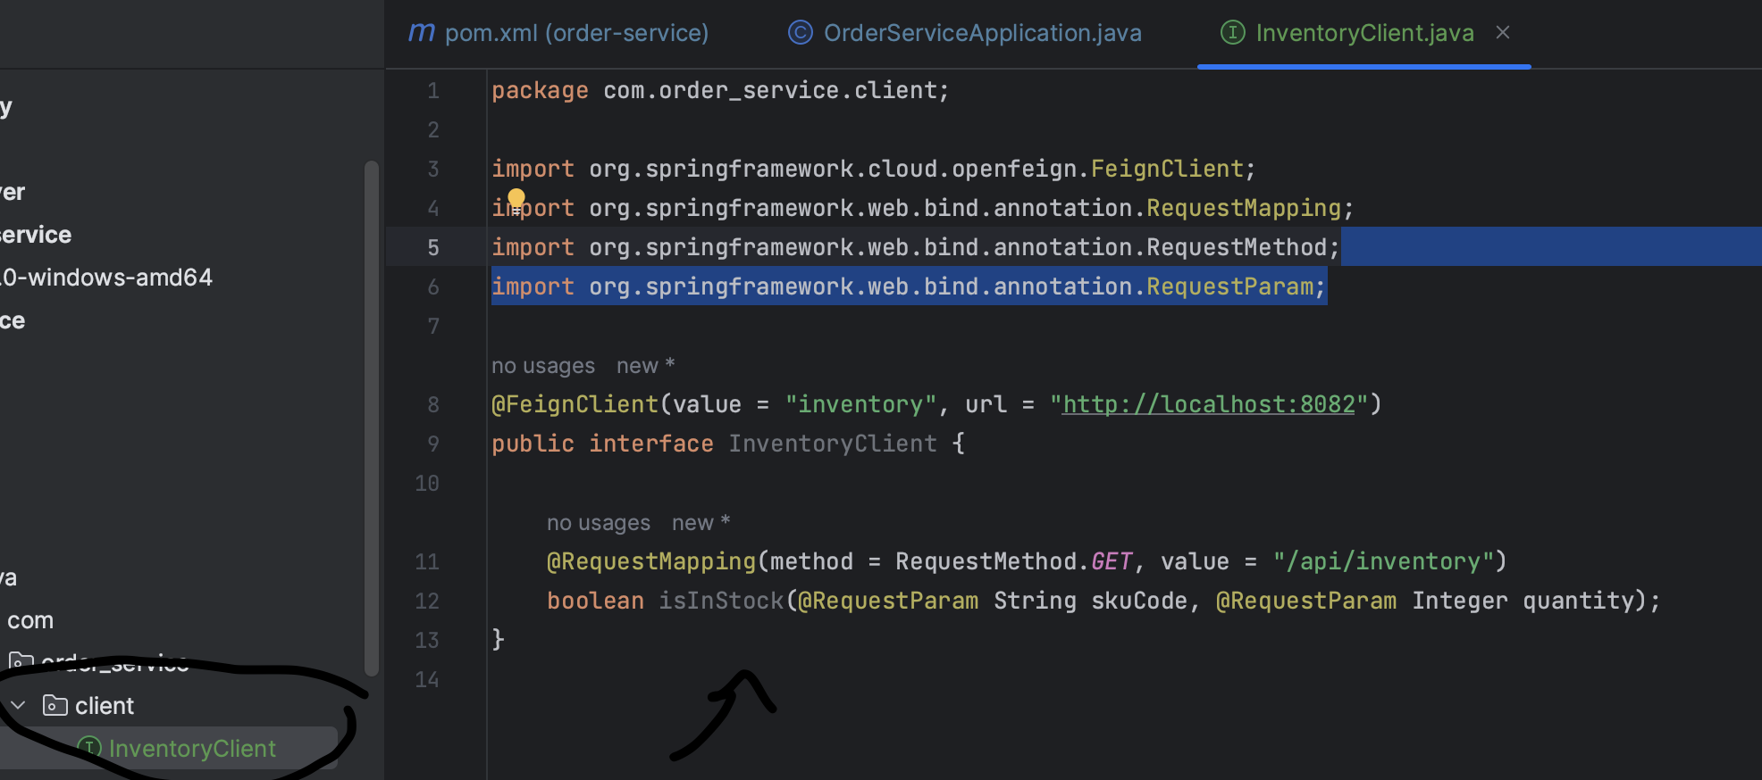

**Flyway migrations error: we can just run ./mvnw flyway:repair

- Integration testing using WireMock:

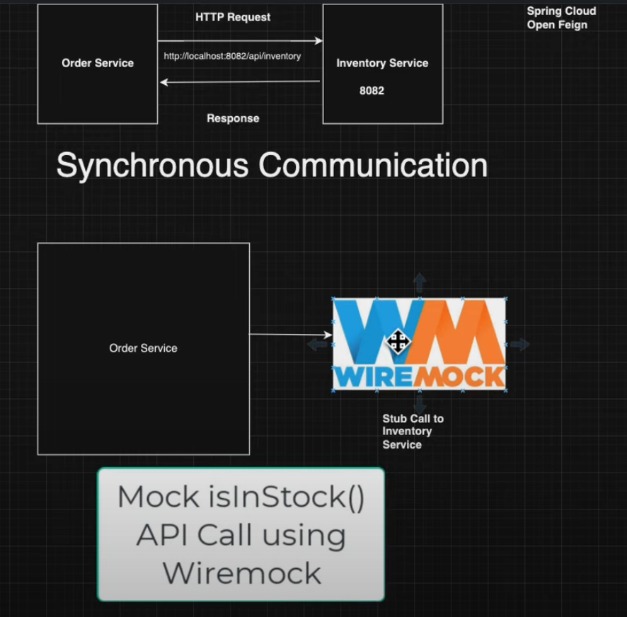

*but I didn’t practice it in my code. Don’t have to.

Part 5:

- API Gateway

- acts as an entry point for requests.

- forwards these request to the downstream microservices.

- commonly used in the distributed systems and microservices architecture.

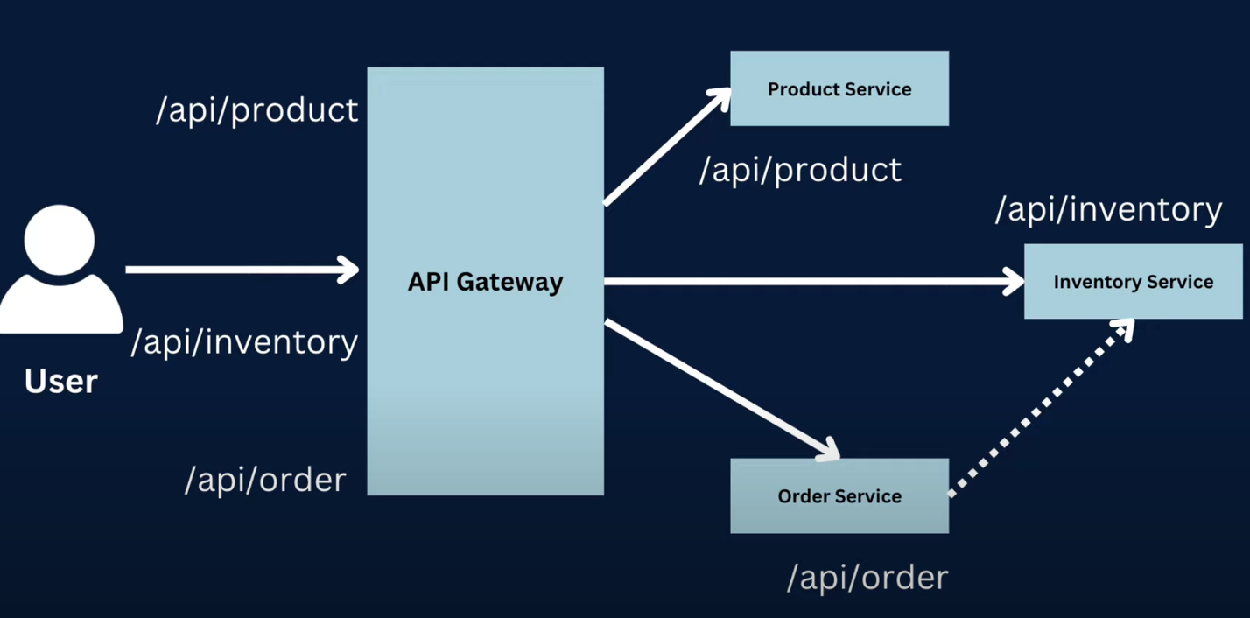

Part 6:

- Learned to create a shell script to run docker-compose commands for all my microservices. Had to put the shell script in the parent directory, and added chmod +x *.sh for execution authorization.

- Spring Security with Keycloak.

- Adds security in Java applications.

- Is open-source.

- can implement sign in with Google, FaceBook, etc.

- OpenID connect, Oauth2.0, etc.

## Oauth 2 using Keycloack

- Implement for:

1. Spring MVC app

2. Single Page App like Angular with Spring Boot Backend

3. M2M Authorization between microservices.

OAuth 2:

- Industry Standard Protocol for authorization between services.

- A stands for Authorization, not Authentication.

- aka Delegated Authorization.

Auth flow:

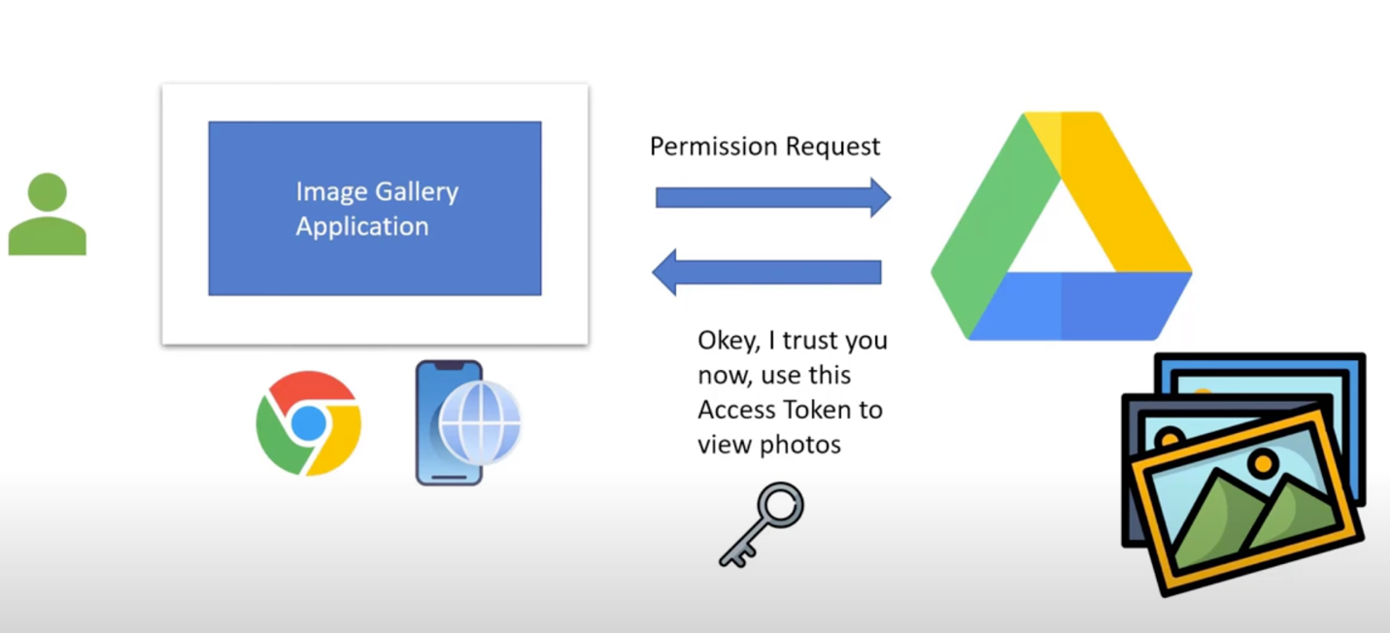

1. User request permission to Google Drive.

2. User will be prompted to login to Google.

3. Once login success, Goggle will provide access token to user.

Oauth2.0 Terminology:

1. Resource or Protected Resource:

- anything that needs to be accessed by the external service. (e.g. Gdrive Photos)

2. Resource Owner:

- owner of above term. (e.g. Google)

3. Resource Server:

- where the resource is hosted or stored. (e.g. Google Drive)

4. Client:

- external service trying to access the resouce. (e.g. External User).

5. Authorization Server:

- server that generates and validates Access Tokens for clients and permissions of Users.

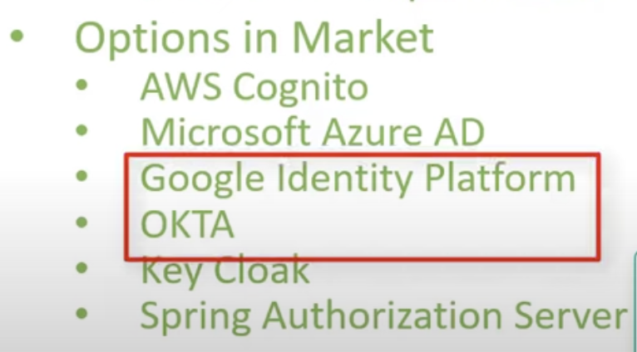

6. OpenID Connect (OIDC)

- Protocol built on top of Oauth2

- Acts as an Identity Layer

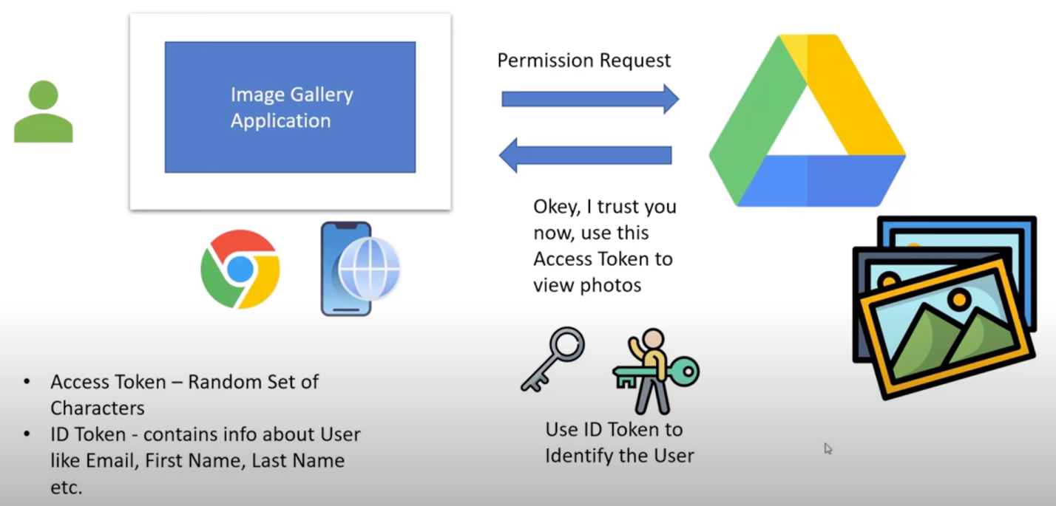

- Notice the user gets 2 tokens:

1. Access Token: used to verify user is authorized to access the resource.

2. ID Token: used to verify the user info/data and identity of user.

KeyCloak

Go to KeyCloak download and run the kc.sh start-dev –-http=8081

You will be directed to a dashboard to create an admin account, then admin login.

First thing to do is to create a Realm.

- a Realm manages a set of users, credentials, roles and groups.

- A user belongs to and logs into a Realm.

- Realms are isolated from one another and can only manage and authenticate the users they can control.

Once you create a Realm, you can go ahead and create a Client.

Remember: Client is an external service trying to access the resouce. (e.g. Spring MVC App).

Keycloack client id: oauth2-demo-thymeleaf-client

Keycloack client secret: RT7aQ8n9JdrdmOLwryYifeo0Us2Ab4SG

User username: amielxavier

User password: Password

Starting your application with oauth2:

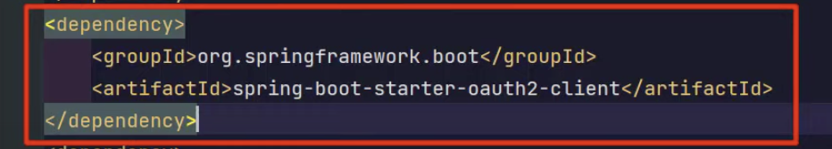

These are the necessary configurations in application.properties or yaml for oauth2:

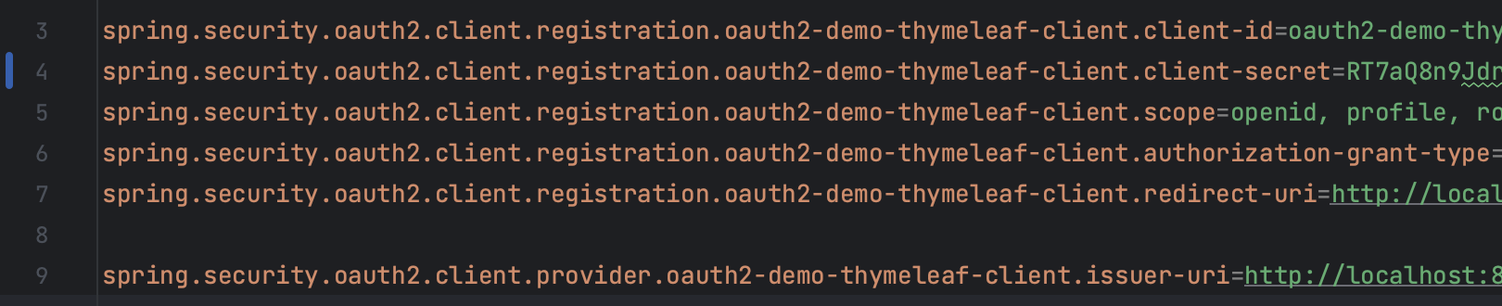

PKCE Authorization Code:

- Spelled as “Piksee” Authorization Code Flow

- Created for Public Facing Clients like web apps developed using Angular, React, or Vue.

- And also mobile apps.

- Considered Best Practice to follow.

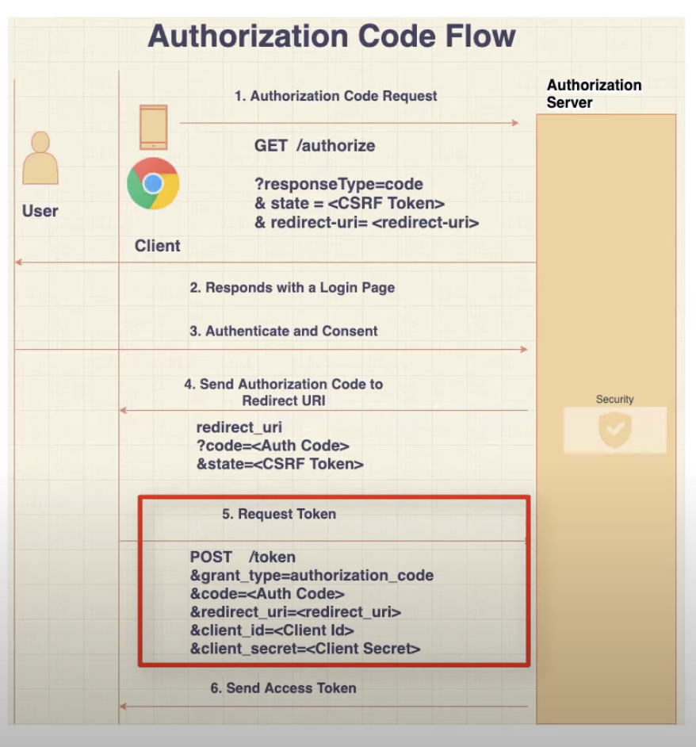

Client has to make a post request with the:

- Client ID

- Client Secret

- Authorization Code.

Meaning we have to have the Client Secret stored in the Client, to make a POST call to the token endpoint.

**PKCE Flow**

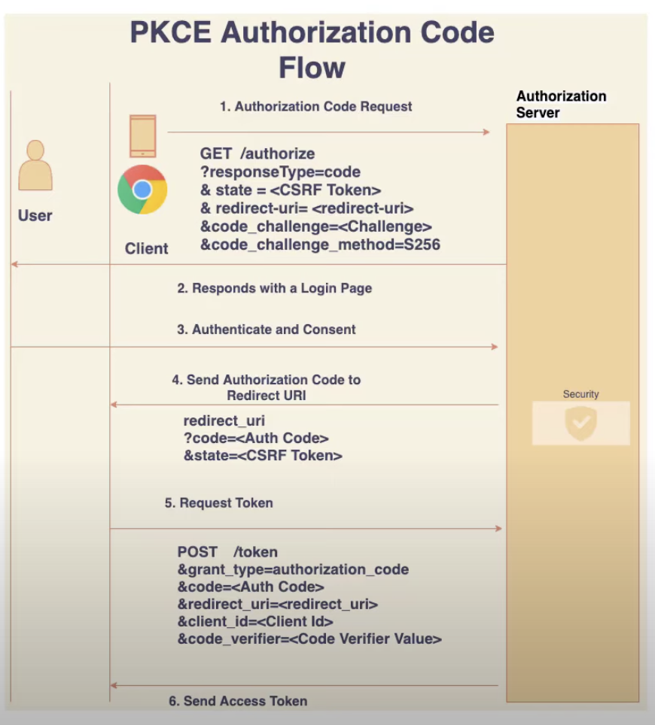

- No need to keep the Client Secret in the Client.

- 2 extra parameters sent:

1. Code Challenge = base64

2. Code Challenge Method = configured in authorization server (S256)

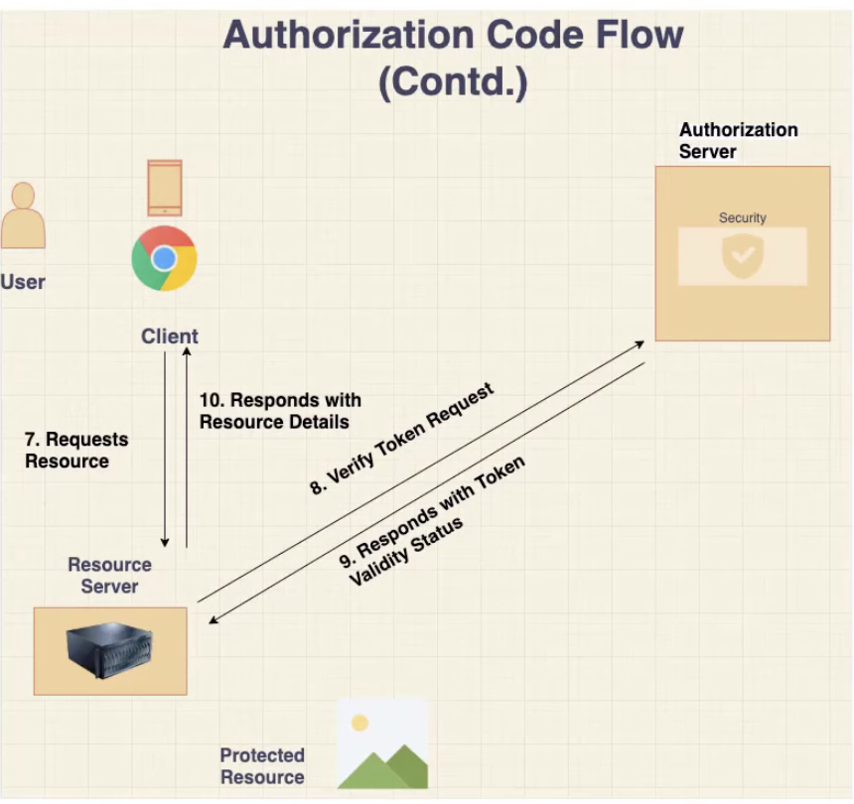

Frontend/Client will make a POST request to this token endpoint:

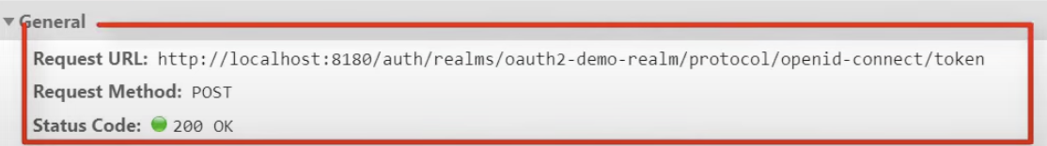

Frontend/Client will receive:

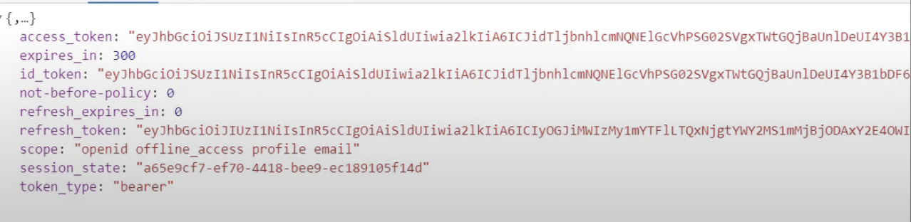

With Angular, we need to add this dependency:

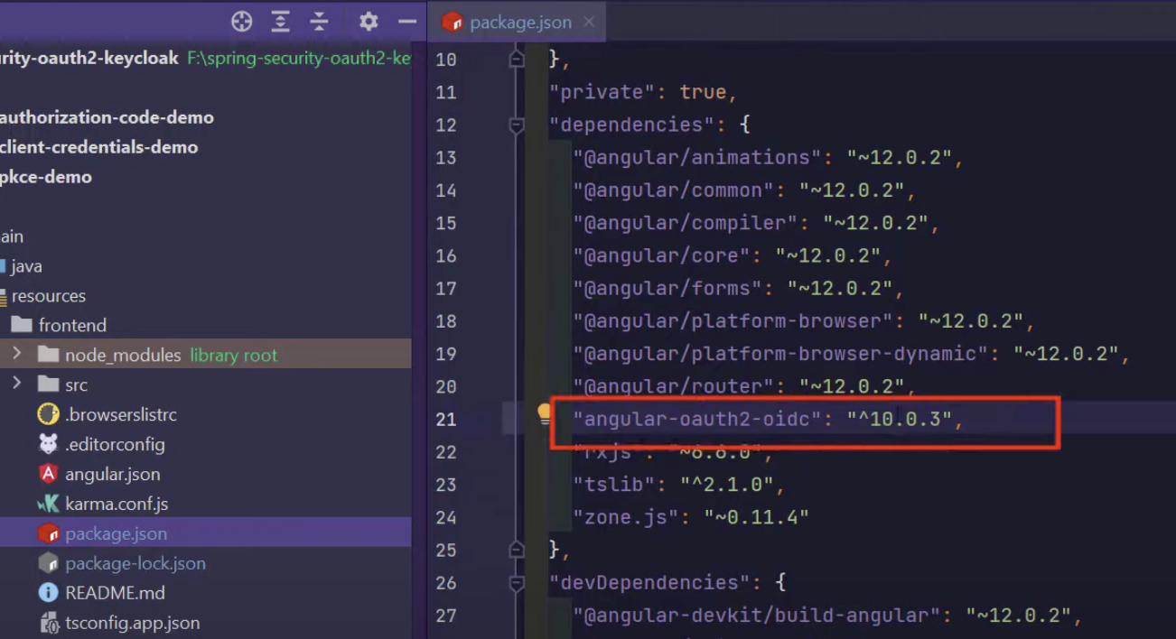

Add these to the config file (auth.config.ts) in Angular:

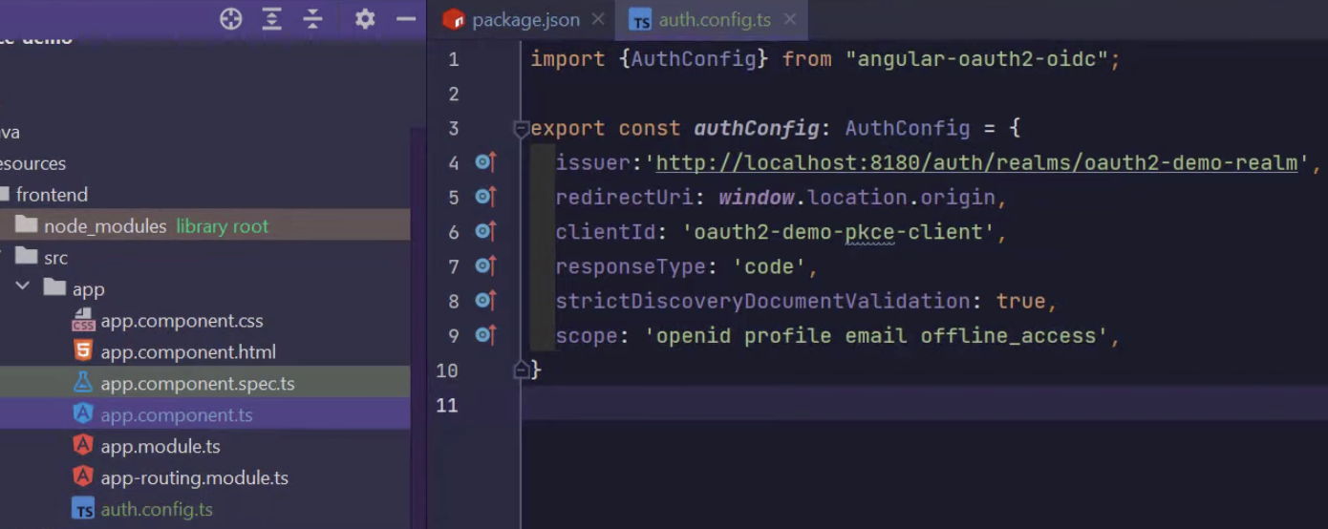

Also add these in module file (app.module.ts) in Angular:

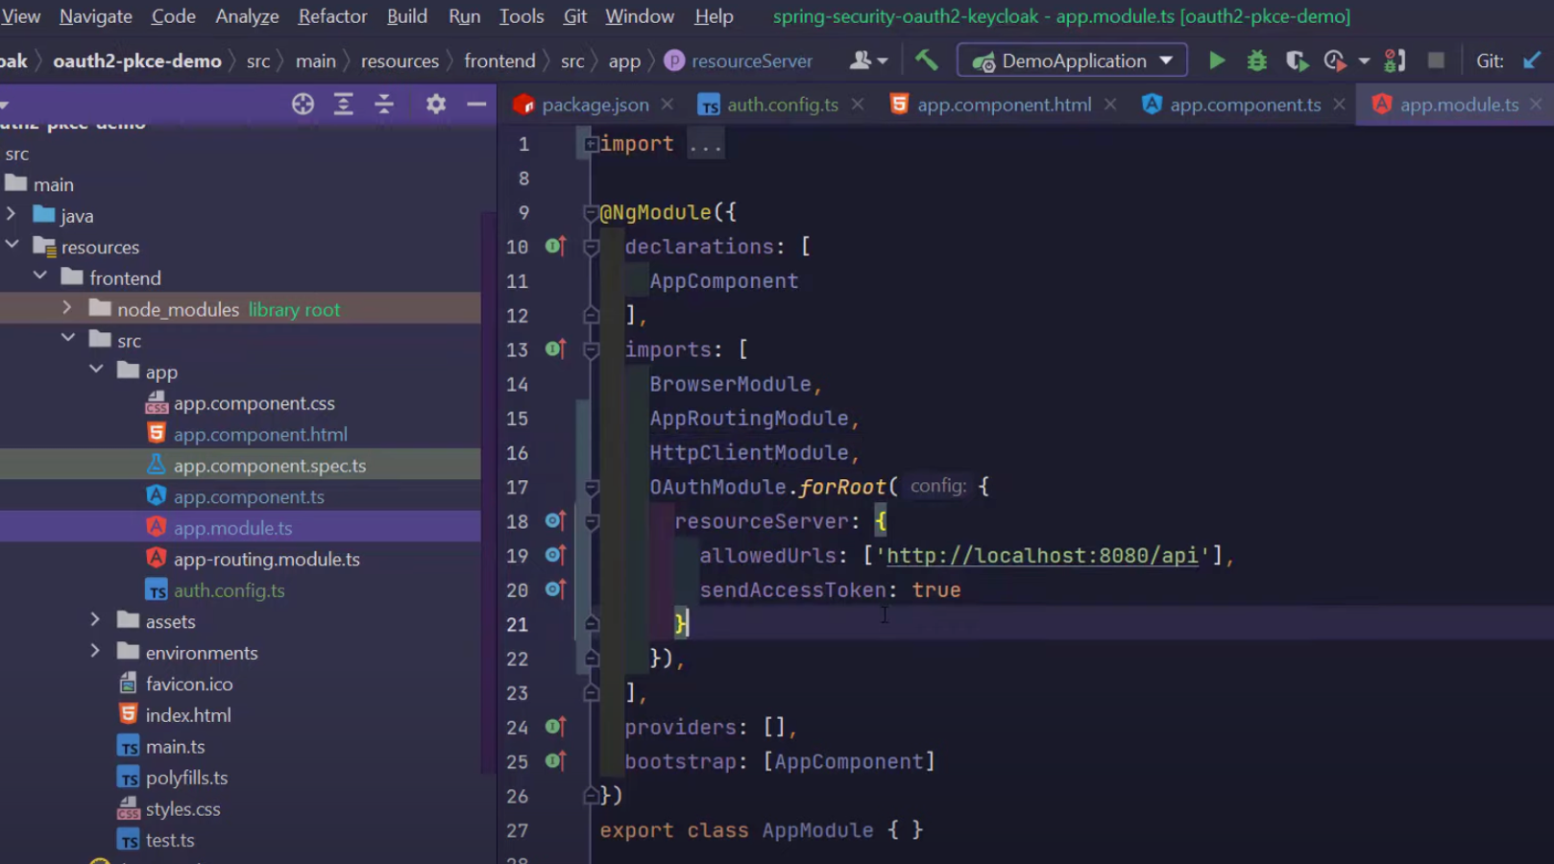

Now in the backend (Spring Boot), add these 3 dependencies:

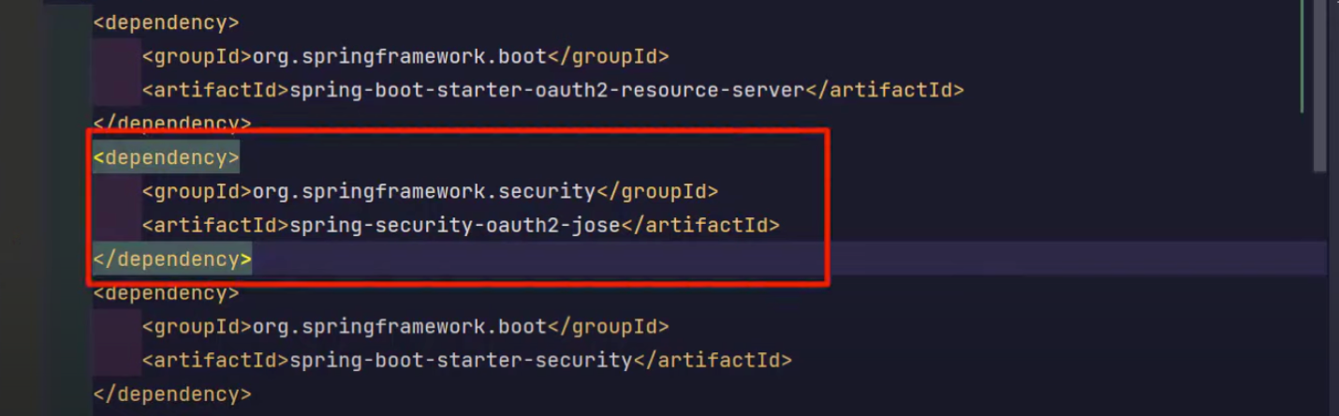

First config we need is:

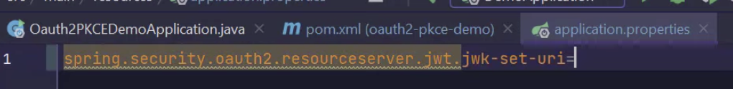

We grab the value for this on OpenID Endpoint Configuration link in Keycloak:

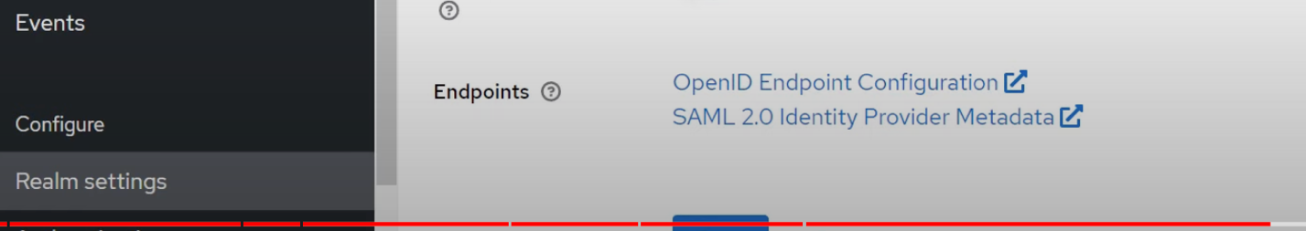

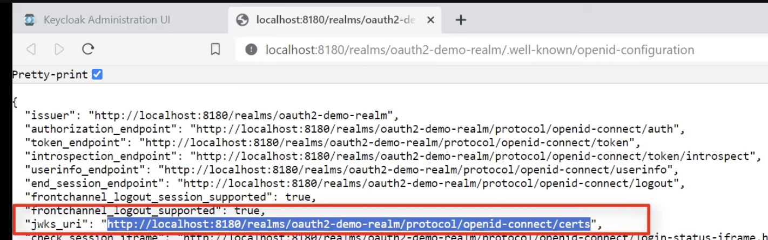

Add this for Spring Security config:

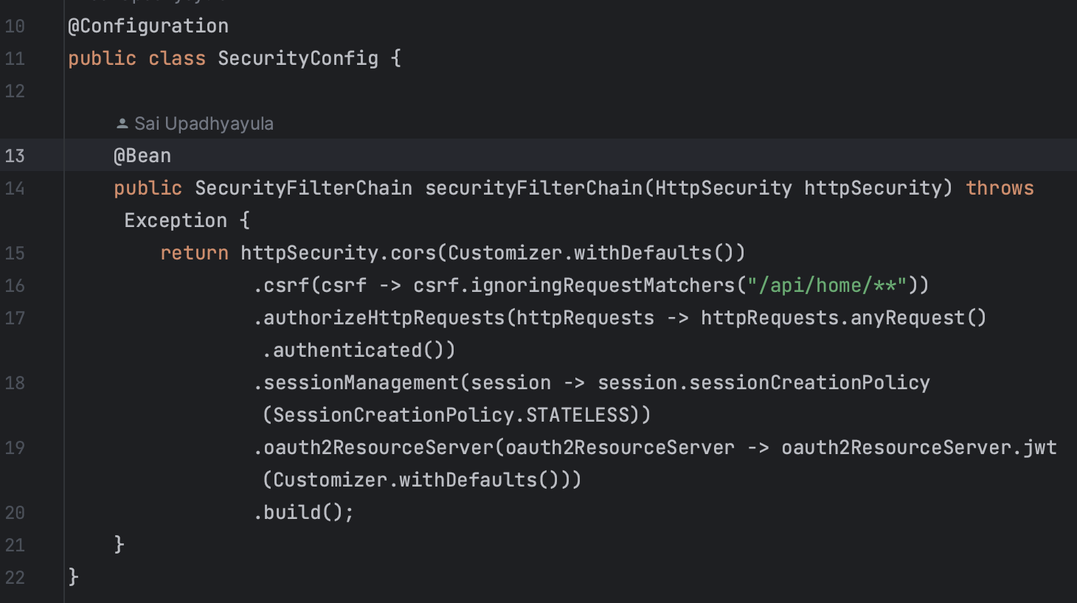

Now in the Frontend (Angular), lets create a class (run command: ng s s app), this will create us app.service.ts. This is where we call the api endpoint in the backend:

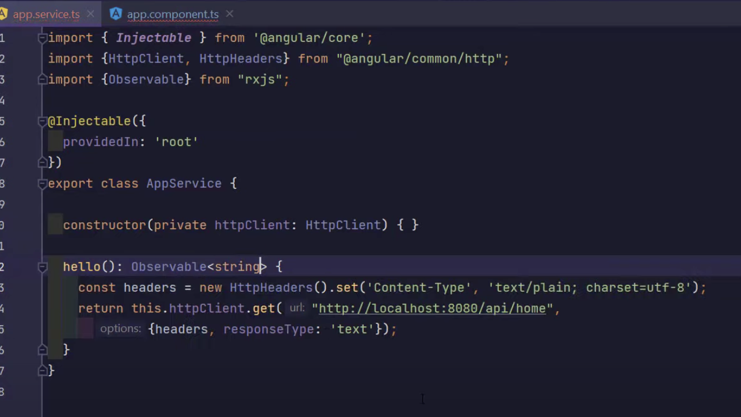

Now let’s inject this call inside app.component.ts:

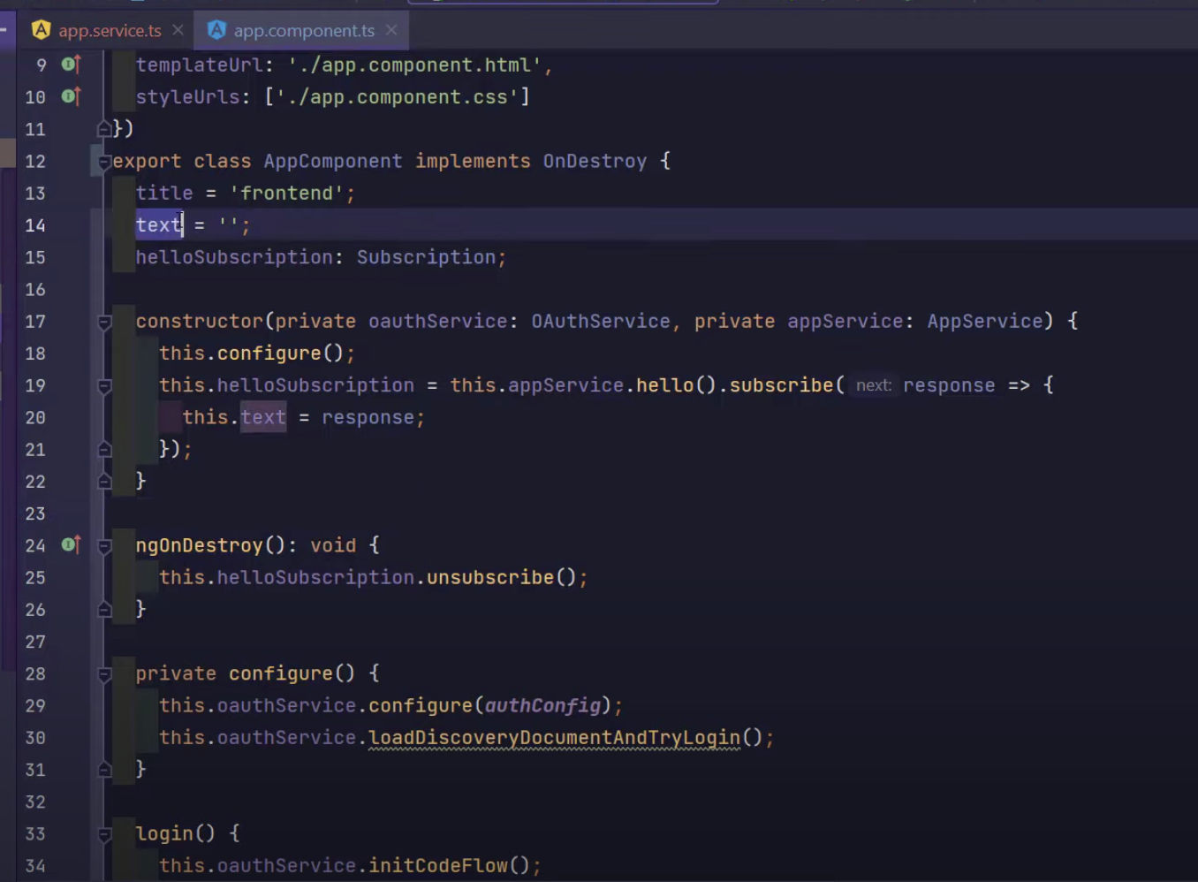

Lastly, display data in html (app.component.html):

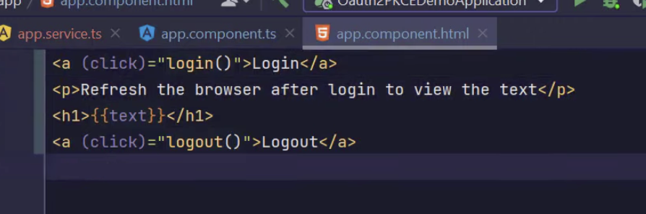

Grant Type: Client Credentials Flow:

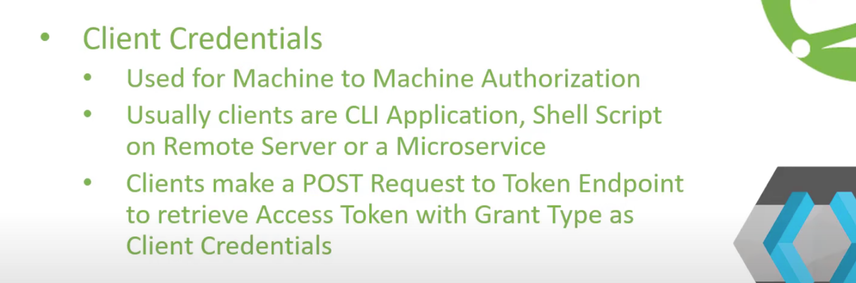

We don’t do the username and password authentication, we just work with the token.

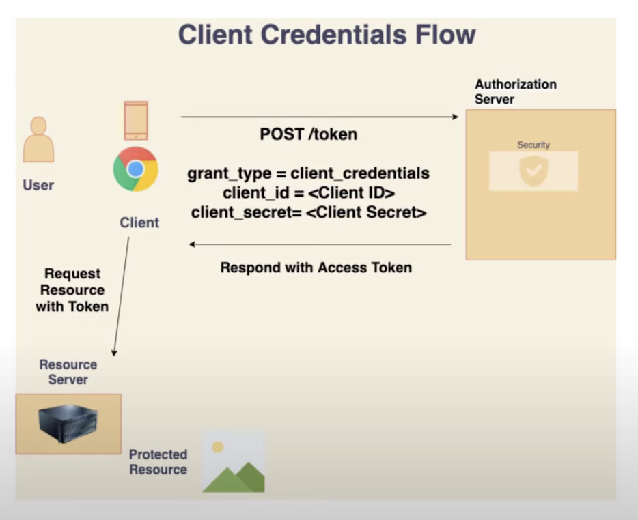

**2 important values: Client ID and Client Secret**

We can grab the token_endpoint on OpenID Endpoint Config link:

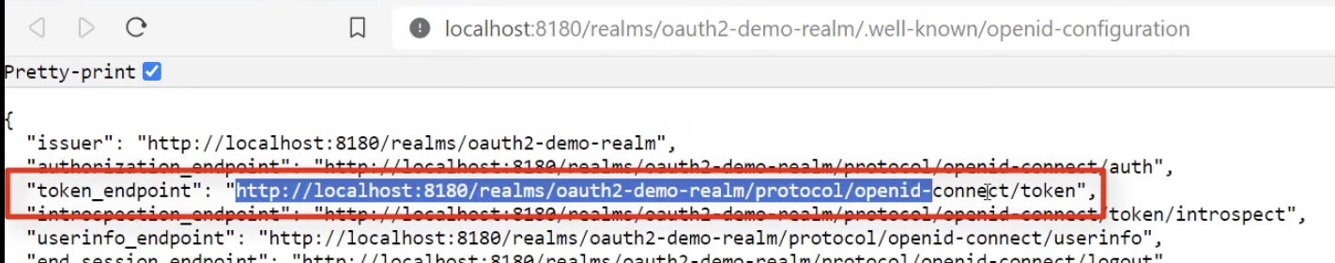

This is where we can make a POST request with the grant_type, client_id, and client_id to grab the access token:

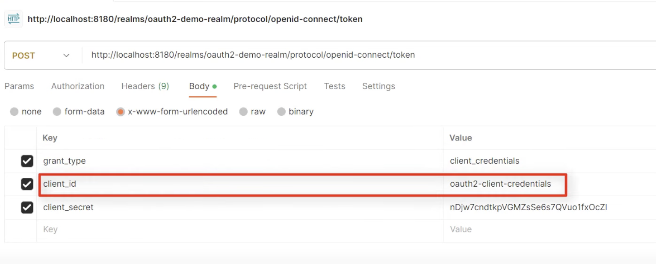

**We need to create a client for every application or project or service.

Settings for client credentials grant in Keycloak:

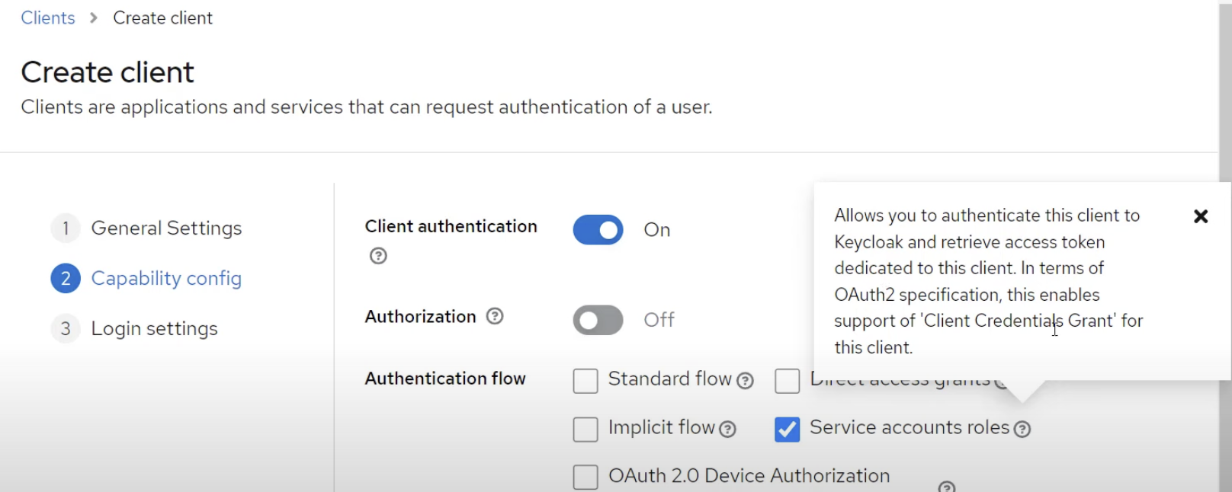

Once client is created, just generate the client secret under “Credentials” tab:

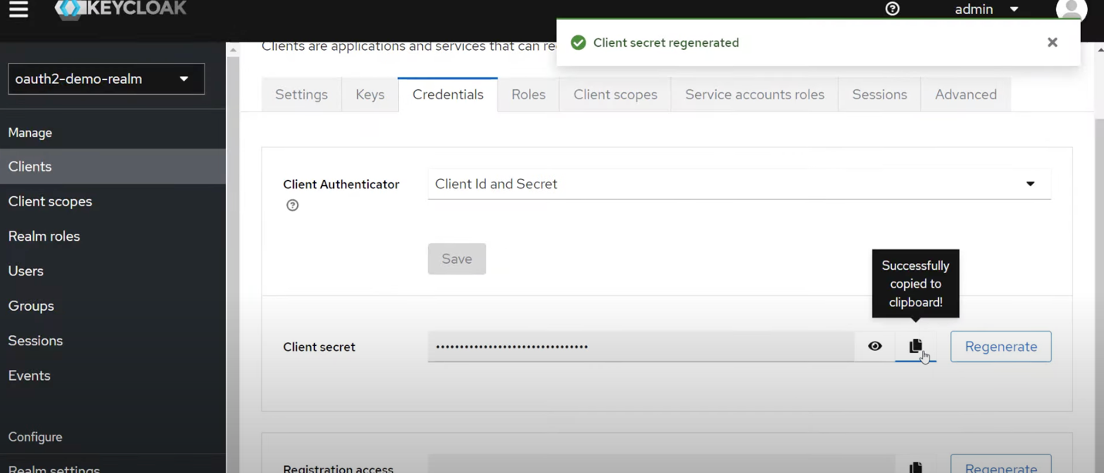

We only need these 2 dependencies for client credentials grant type:

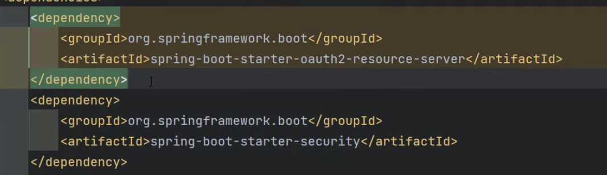

Spring Security config for client credential flow:

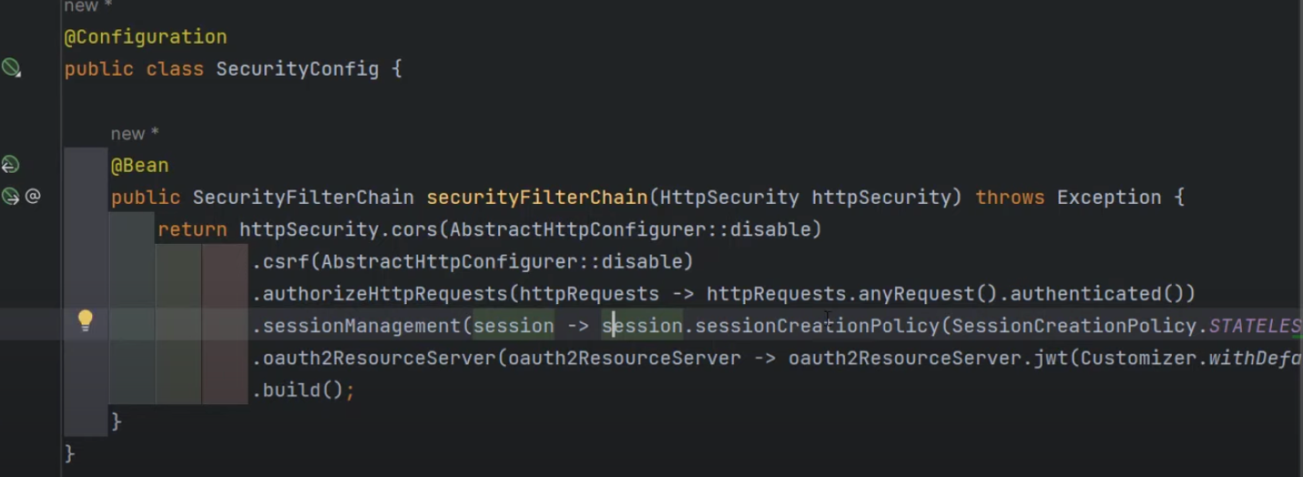

Add to config file:

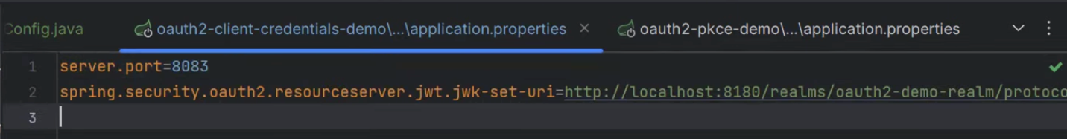

Under Authentication in Postman:

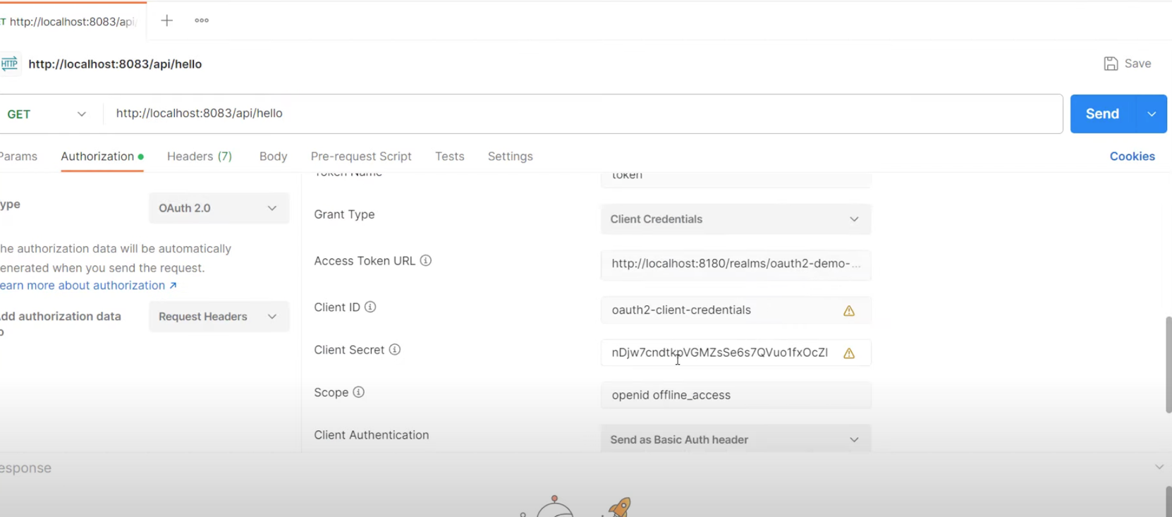

Securing our Api-Gateway using Auth Server called KeyCloak

Now that we have setup the Keycloak to our application, the security is now working:

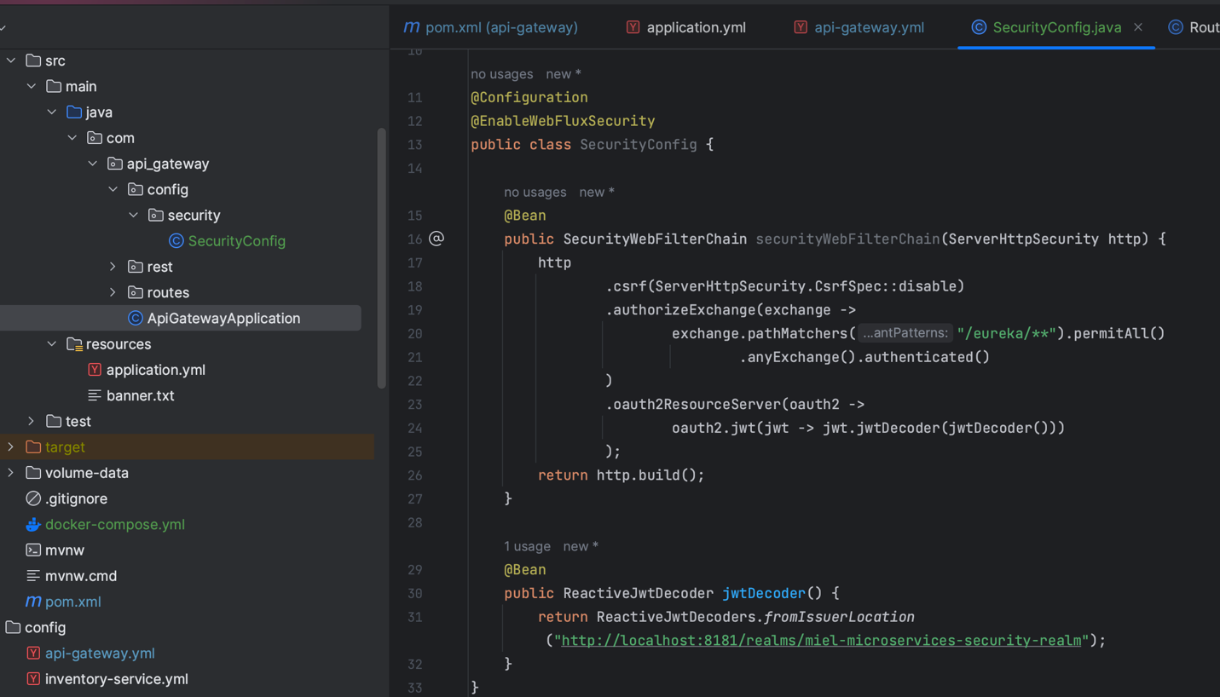

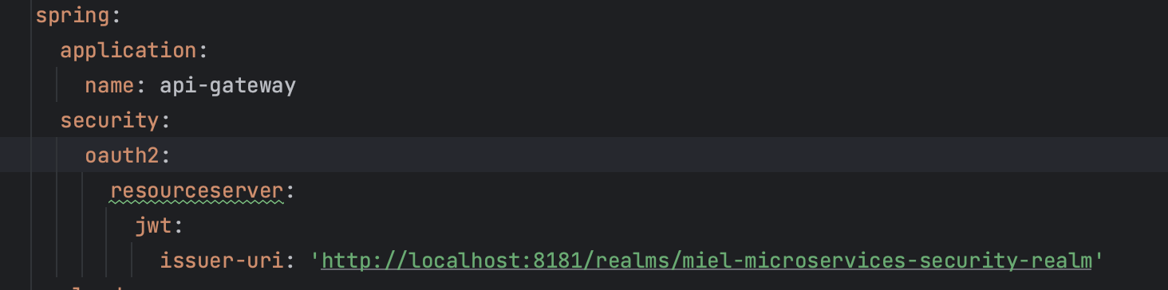

How to generate a token to use as JWT token to run the api endpoint:

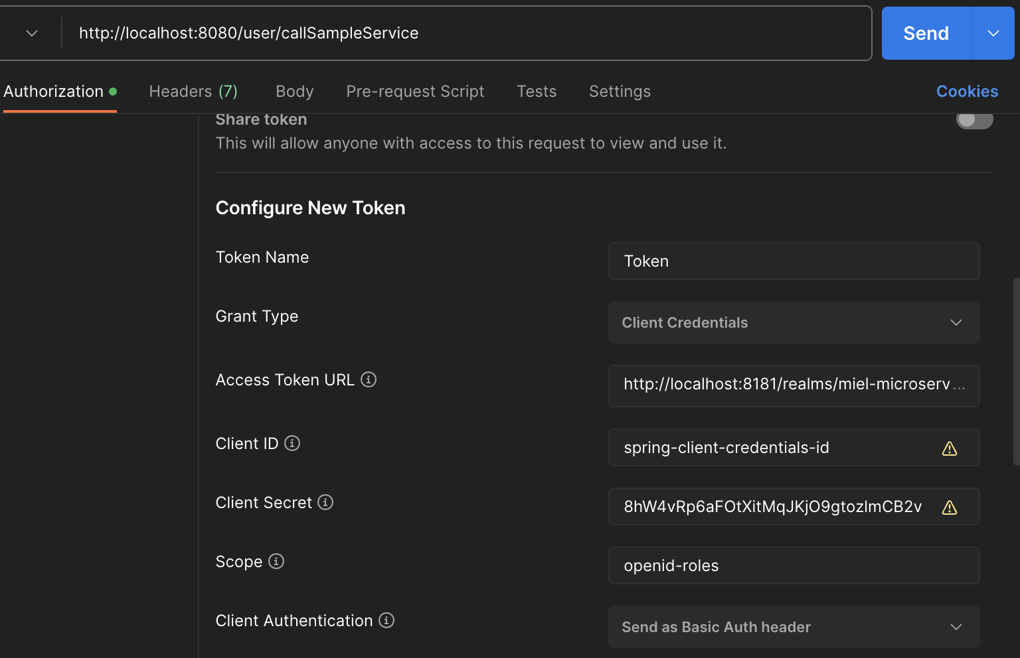

Get token_endpoint here for Access Token URL:

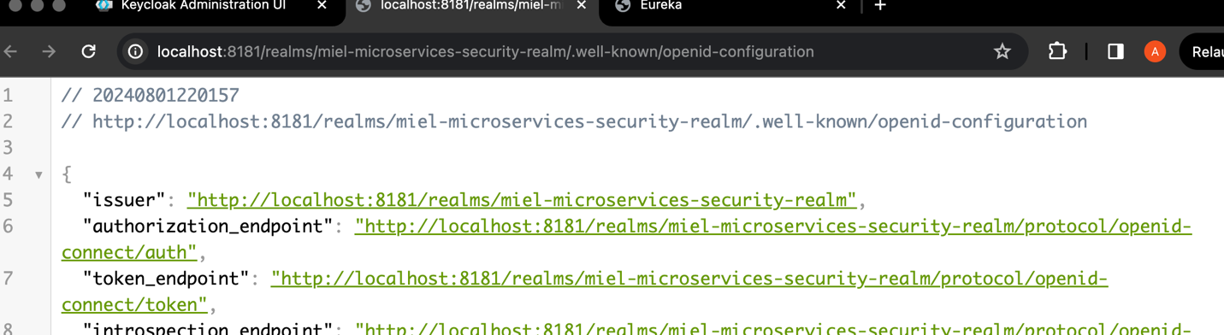

Client id and secret is here:

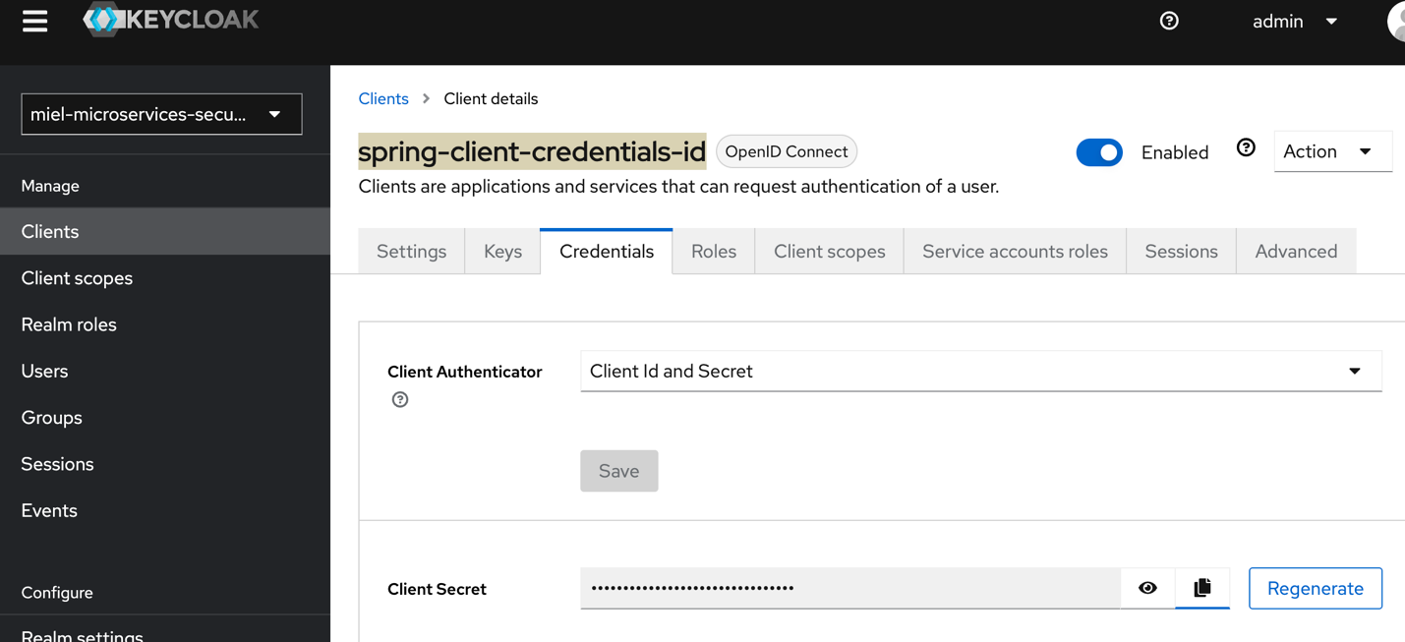

Part 7:

- All about spring doc open api.

- Straight forward configuration.

Part 8:

- Aggregate Documentation and Refactoring

- Centralized swagger documentation for all microservices inside api gateway.

- Refactored OpenFeign to a newer version/code:

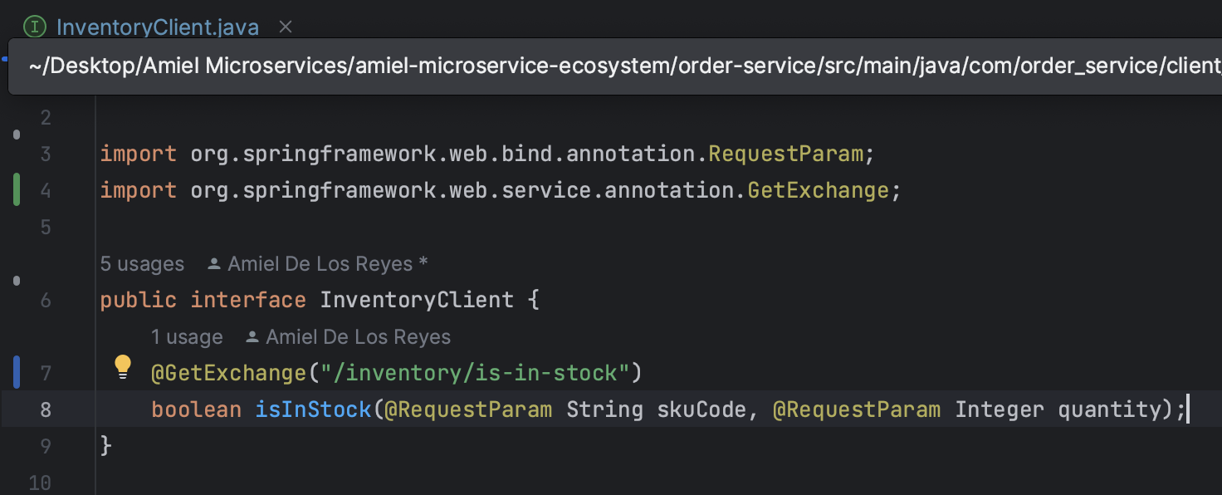

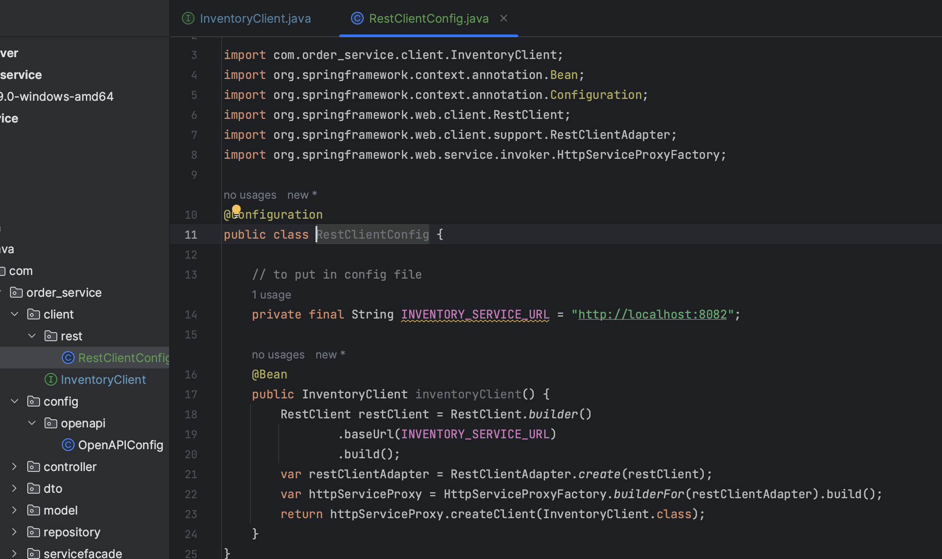

Part 9: Circuit Breaker with Resilience4j

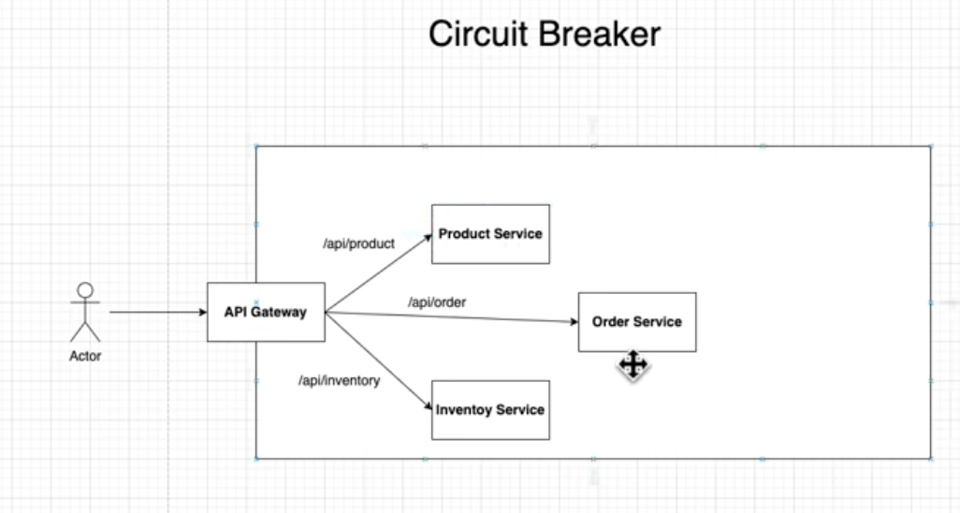

- A Circuit Breaker acts as a blocker when a microservice is down or very slow.

- Think of it as a blocker to a electricity path. When the machine that’s connecting to that wire is down, this circuit breaker blocks any incoming electricity to the machine. Similar to the Circuit Breaker in software, any incoming request to the down service will be blocked in the api-gateway.

- We use the library Resilience4j for the circuit breaker.

- We use Spring Cloud Circuit Breaker dependency.

Add these dependencies:

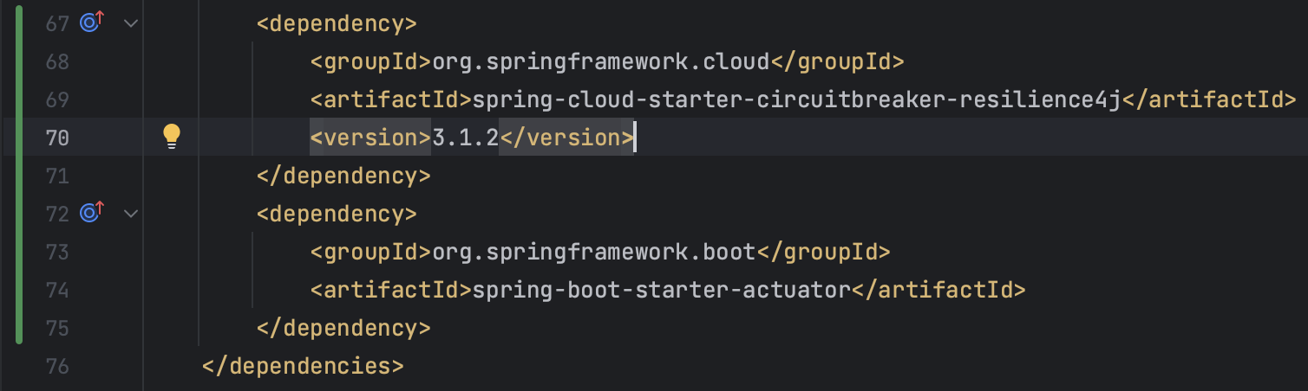

Add these configs:

*# Actuator Endpoints*management:  
 endpoints:  
 web:  
 exposure:  
 include: '*'  
 endpoint:  
 health:  
 show-details: always  
 health:  
 circuitbreakers:  
 enabled: true  
  
  
*# Resilience4j Properties*resilience4j:  
 circuitbreaker:  
 configs:  
 default:  
 registerHealthIndicator: true  
 slidingWindowType: COUNT_BASED  
 slidingWindowSize: 10 *# number of requests at a time to check if we will turn on CB* failureRateThreshold: 50 *# from the 10 requests, CB will turn on if 50% of request is failure* waitDurationInOpenState: 5s   
 permittedNumberOfCallsInHalfOpenState: 3  
 automaticTransitionFromOpenToHalfOpenEnabled: true  
  
 *# Resilience4j Timeout Properties* timelimiter:  
 configs:  
 default:  
 timeout-duration: 3s

Circuit Breaker State:

- By default, In Closed state

- Open means the CB is blocking the incoming requests because of failure.

- If CB notices the requests are becoming successful or the service is up, it goes to Half-Open state (only some requests can come in):

- if requests or service is still fail, then it goes back to Open state.

- if all is success, then it goes to Closed state and incoming requests are now allowed.

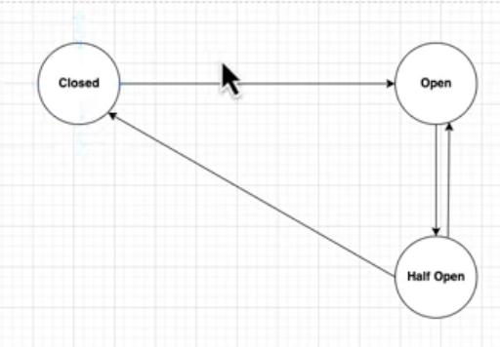

Part 10: Setting Up Angular App

- We made sure that we have the latest version for node.js, npm, and Angular CLI (ng).

Setting up Angular: <https://programmingtechie.com/2024/06/09/spring-boot-microservices-tutorial-part-7/>

** I ran into the issue of CORS multiple Acces-Control-Allow-Origins that took me hours, the issue was that I was having multiple of those. The resolution was that the configuration on the backend with the CORS should match the one in Keycloak.

For example, for Web Origins in Keycloak, I had “*” as the value, I changed it to <http://localhost:4200> (which is the same in the backend configuration:

.cors(cors -> cors.configurationSource(request -> {  
 CorsConfiguration config = new CorsConfiguration();  
 config.setAllowedOrigins(List.*of*("http://localhost:4200")); // Allow specific origins  
 config.setAllowedMethods(Arrays.*asList*("GET", "POST", "PUT", "DELETE", "OPTIONS")); // Allow specific methods  
 config.setAllowedHeaders(Arrays.*asList*("Authorization", "Content-Type")); // Allow specific headers  
 config.setAllowCredentials(true); // Allow credentials (cookies, authorization headers, etc.)  
 return config;  
}));

And IT WORKED!!

# TO Dos:

* Better exception handling for better response body in Postman. (The exception handling in invetory-service isInStock()).
* Fix the logic of when the customer places an order, then we deduct the quantity to the inventory, ONLY IF the order is confirmed or shipped.
* Add logback xml for logging for every microservice
* Fix up Placing order with order-service, and product-service, inventrory-service, etc.
* Add order-service, inventory-service, and product-service configurations on config directory, then test calling
* Register eureka clients order-service, inventory-service, and product-service to eureka server (work on order-service and product-service not working and not being able to connect to mysql db or db). (NOTE: had to explicitly put configs in the main yaml file `application.yml`)